**Open Street Maps in Unreal**

Jason Beal

Digital Media East Tennessee State University

James Livingston

April 29, 2024

**Abstract**

This research explores the integration of geospatial data from OpenStreetMap (OSM) into Unreal Engine, a prominent platform in modern game development known for its visual fidelity and flexibility. As players increasingly seek immersive experiences in expansive environments, developers are driven to innovate methods for using procedural tools to swiftly create highly detailed assets. The integration process involves extracting information about terrain, roads, buildings, and other geographic features from OSM data using various online services and tools. Procedural software like Houdini aids in processing this data to generate game-ready 3D models of buildings and road networks, which undergo additional steps like retopology to optimize them for real-time applications. Plugins for Unreal Engine further streamline the integration process, enabling developers to efficiently incorporate OSM-derived assets into their projects. Once imported, these assets can be enhanced using Unreal's Niagara system for dynamic visual effects to enhance interactivity. This research demonstrates the potential of this process and showcases its application in creating immersive gameplay.

**Introduction**

Advancements in geospatial data utilization have created an opportunity for the creation of large-scale assets created for integration within the Unreal Engine. By leveraging real-world street layouts and architectural data, users can import and integrate these assets into real-time gaming environments. The integration of procedural generation tools like Houdini enables swift generation of intricate assets, vastly enriching the visual fidelity of game maps.

Leveraging Unreal Engine's robust particle effects system, Niagara, further enhances the immersive experience by imbuing environments with lifelike realism. One notable application of this technology lies in the direct integration of imported road networks with C++ functionality through blueprints using the Street Map Plugin for Unreal Engine (Fricker, 2023) without the labor-intensive process of manual asset creation. These blueprints facilitate a myriad of interactions, including the implementation of AI navigation algorithms tailored to support desired gameplay mechanics. This research endeavors to delve into the practical implementation of these assets within the context of a city-building gaming environment, emphasizing the seamless fusion of geospatial data, procedural asset generation, and cutting-edge visual effects elements.

**Open Street Maps into Unreal**

In modern game development, achieving high levels of realism has become a powerful goal for developers. Players increasingly demand immersive experiences that include massive environments that mimic real-world areas, prompting game creators to explore innovative techniques for achieving authenticity. One such approach explored in this research is the integration of geospatial data, which provides a wealth of real-world information that can enhance the fidelity of game environments procedurally while saving many hours of labor.

**Figure 1**

*Geospatial Data*

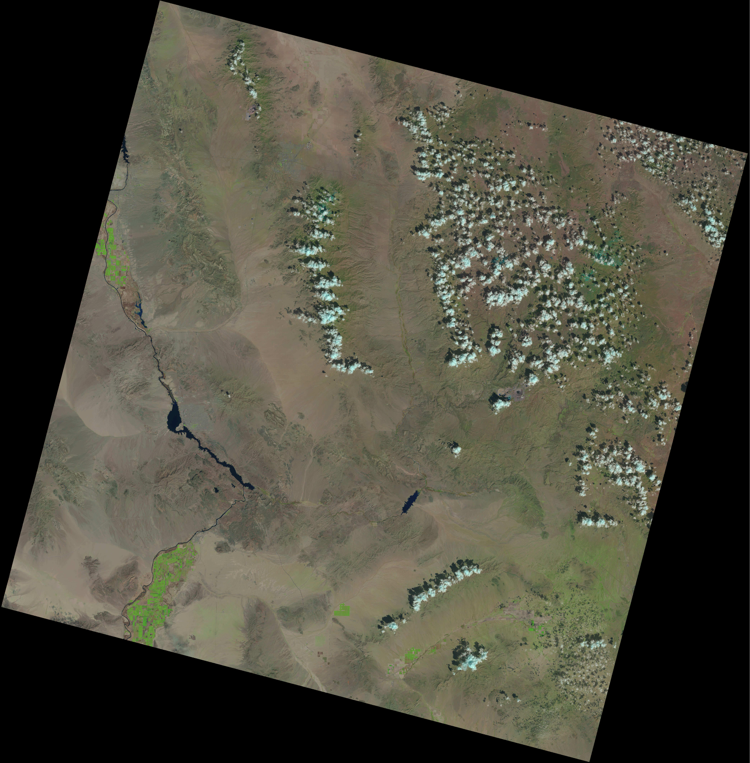

A powerful online tool from openstreetmap.org can provide Open Street Maps (OSM) data (OpenStreetMap 2004). The OSM data from these services are downloaded in formats such as .geojson, .gpx, .kml, and .osm. These formats typically show as a heightmap that Unreal can translate as a very rough terrain. Platforms such as openstreetmap.org provide means to download OSM data, enabling developers to extract detailed information about terrain, roads, buildings, and other geographic features. These services give the user the ability to draw a square section of the globe and export any data on the buildings contained therein, including shape.

**Figure 2**

*Open Street Maps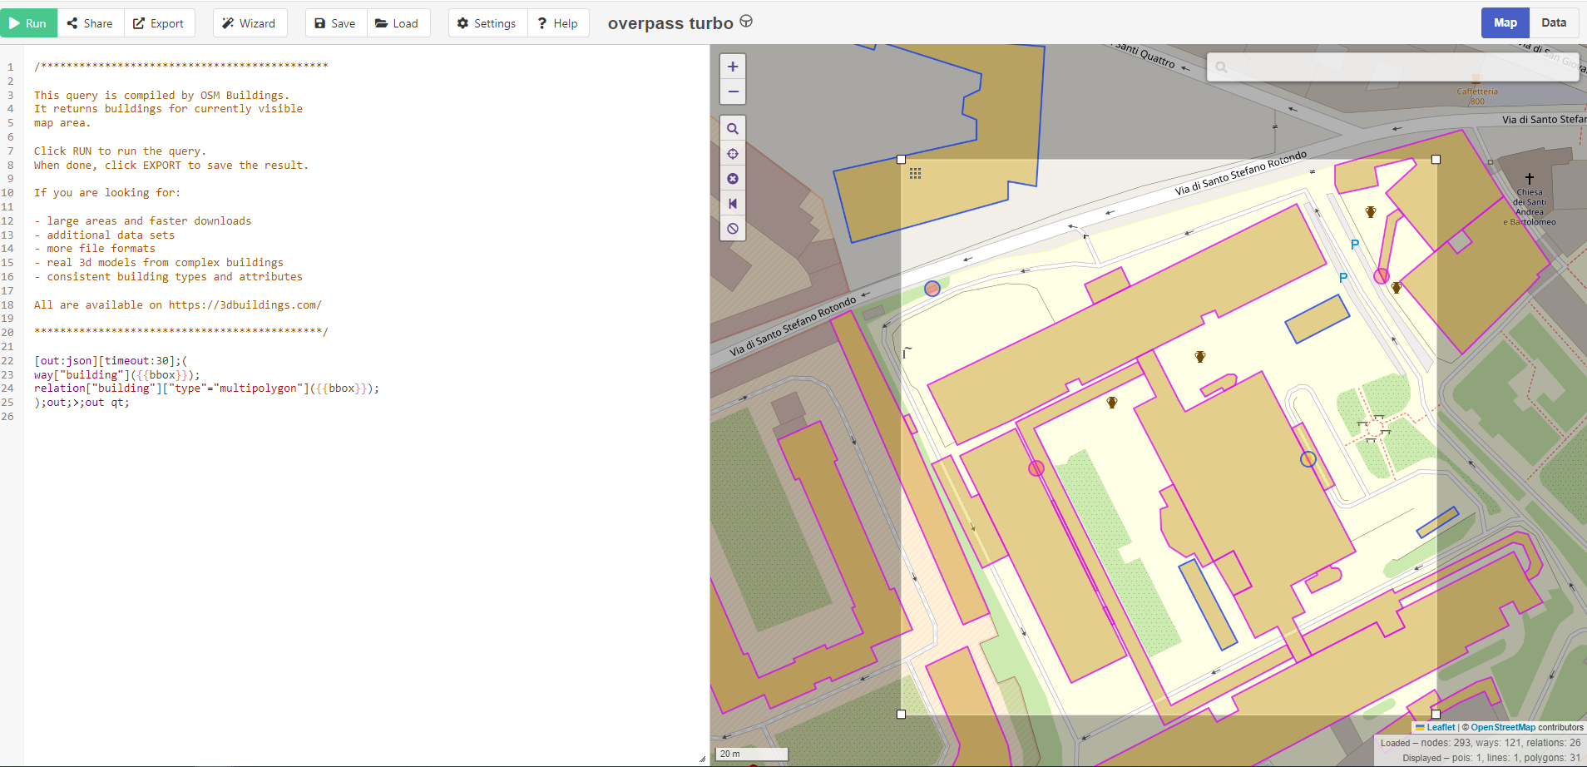*

The integration of OSM data into Unreal Engine involves a multi-step process facilitated by specialized tools and software. With Houdini, developers can harness specific tools provided by SideFX to process OSM data and generate 3D models of buildings and road networks (Houdini 2023).

**Figure 3**

*Houdini Import*

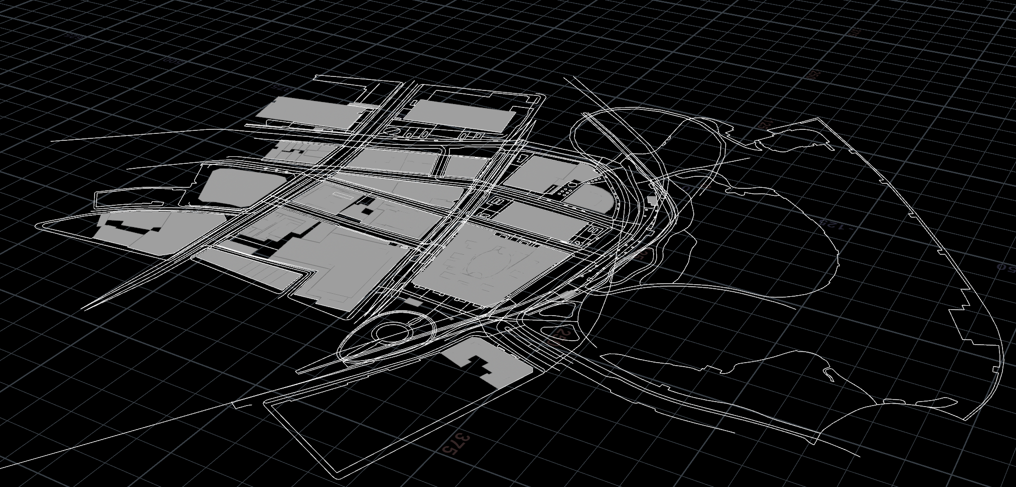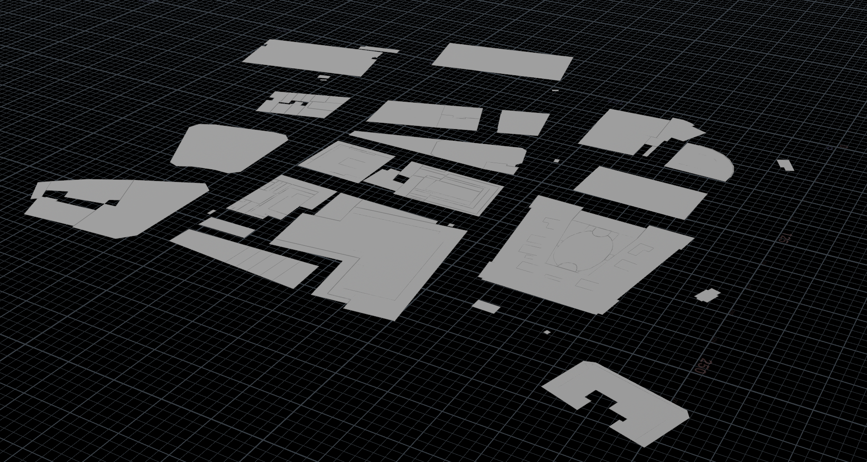

A “Labs OSM Buildings” node is then used to create 3D models in the shape and location of the buildings based on that data. The topology on these generated models will need some retopology to be made game-ready (Houdini 2023).

**Figure 4**

*Procedural building retopology*

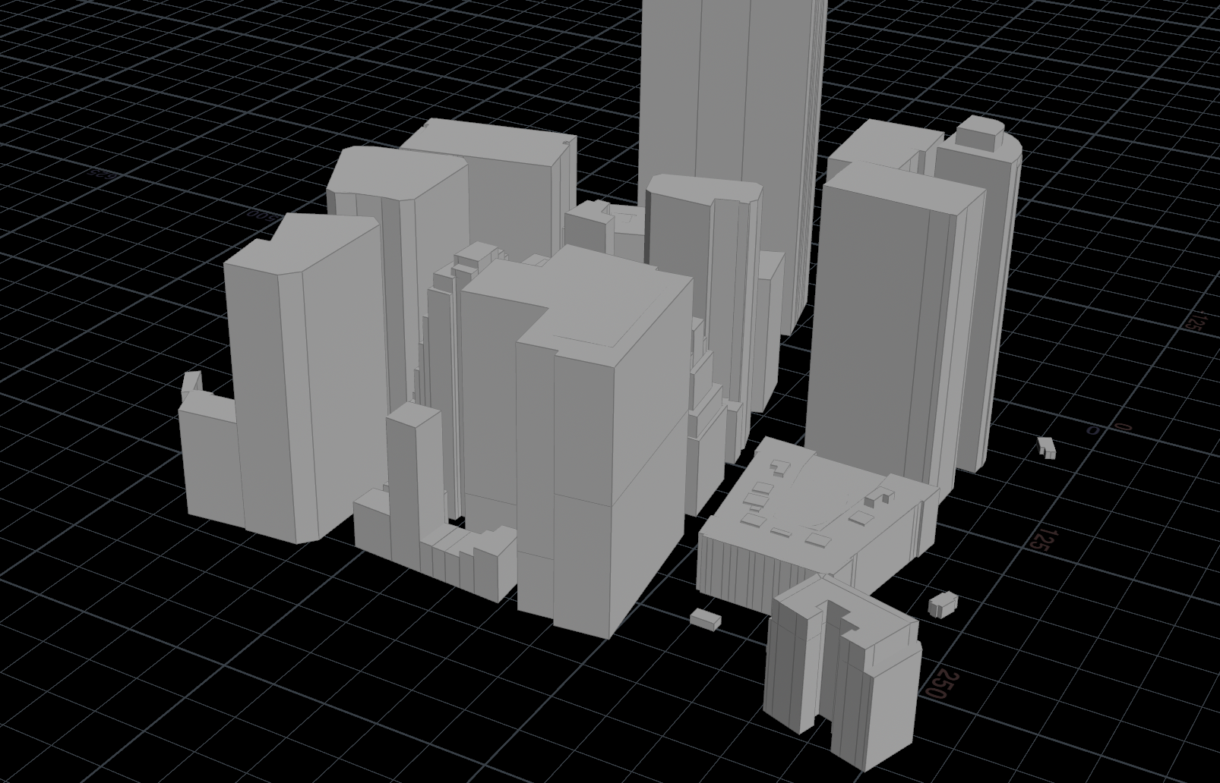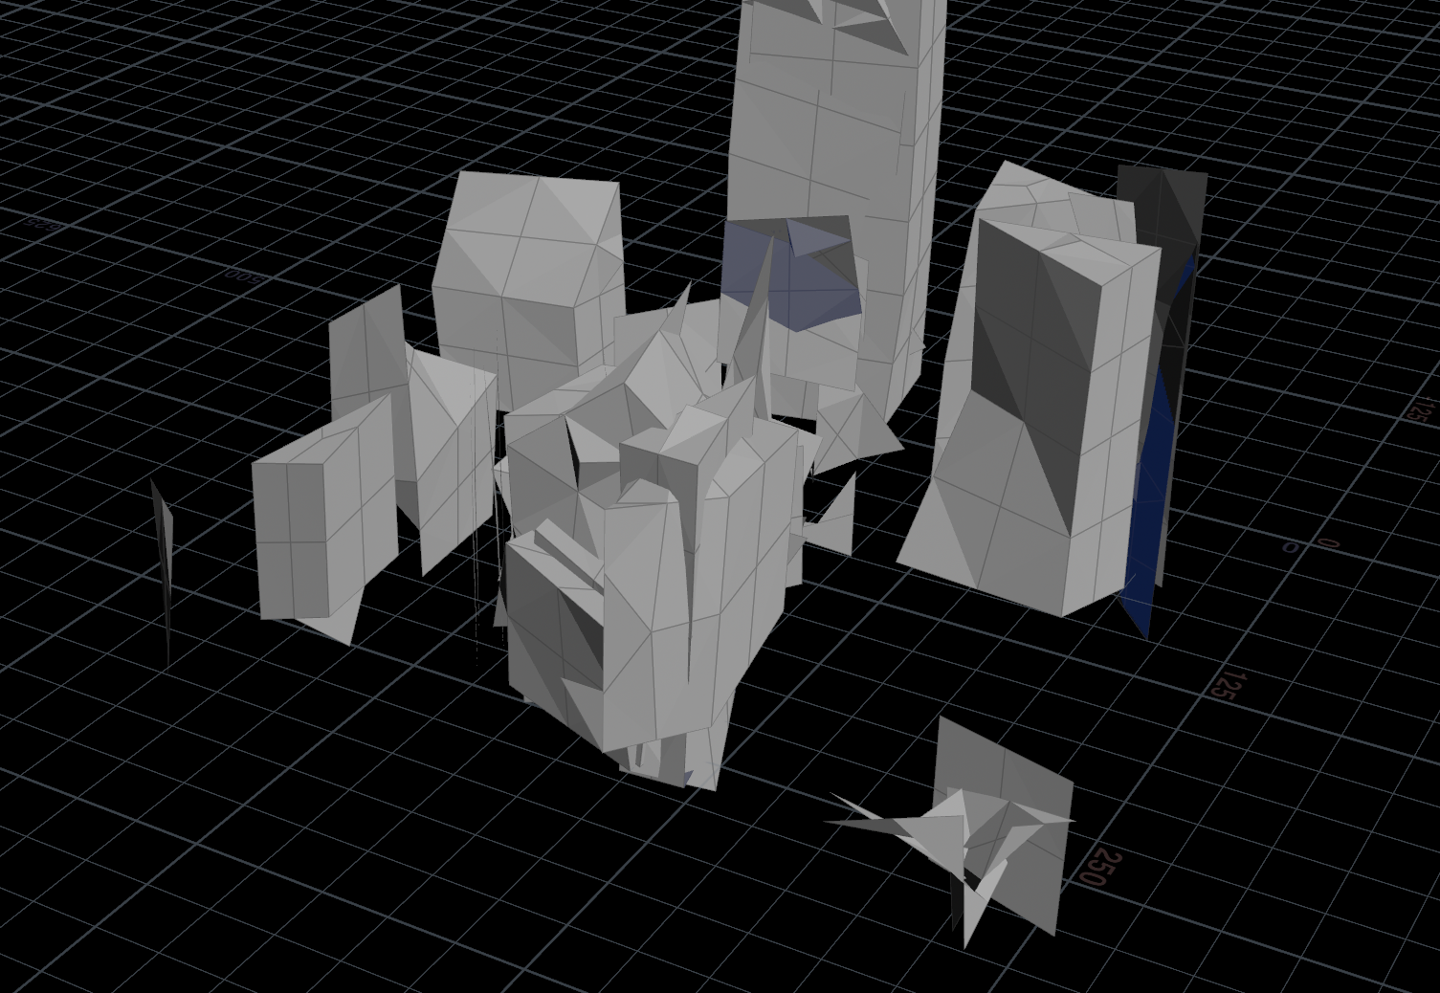

The polyreduce, quadrangulate, bevel, and clean nodes can achieve acceptable models to be exported with a “ROP fbx” node (Houdini 2023).These models are derived from the data extracted from OSM, enabling developers to recreate real-world structures within the virtual environment. However, additional steps such as retopology are often required to optimize these models for use in real-time applications like games. Once prepared, the models can be exported as .fbx files for integration into Unreal Engine.

**Figure 5**

*Houdini Procedural Nodes*

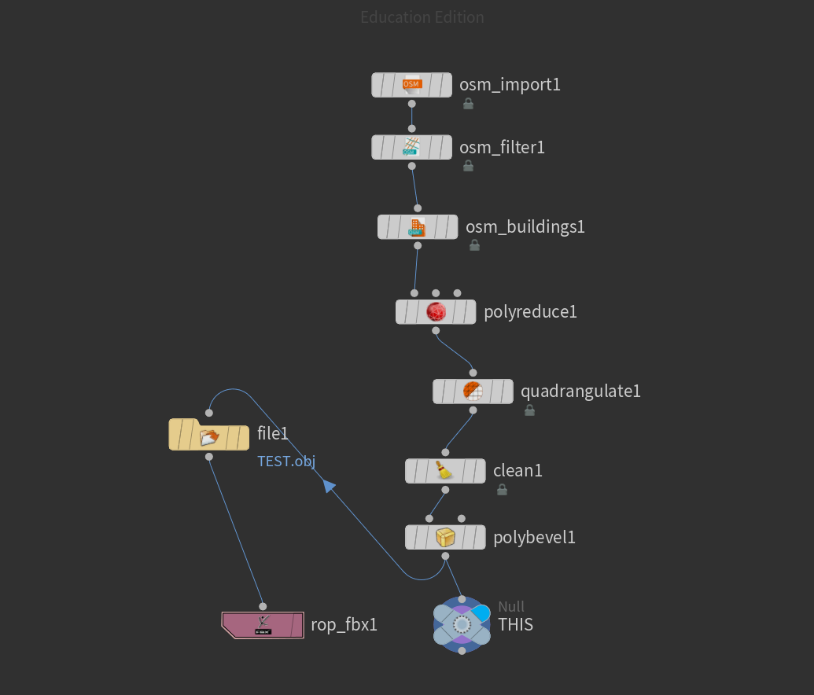

Upon importing the generated models into Unreal Engine, developers gain access to a wide array of tools and features for further refinement and customization. Plugins tailored for C++ Unreal projects streamline the integration process, allowing developers to efficiently incorporate OSM-derived assets into their projects. Once imported, these assets can be manipulated and enhanced using Unreal Engine's robust suite of editing tools. Notably, the integration of Niagara VFX enables developers to apply dynamic visual effects to imported meshes, enhancing the realism and interactivity of the virtual environment.

A sprite emitter that uses mesh reproduction can appropriately replace the buildings with sprites when it is activated with a blueprint. This gives the appearance that the buildings on this city skyline have fallen to dust.

**Figure 6**

*Unreal Engine Plug-in*

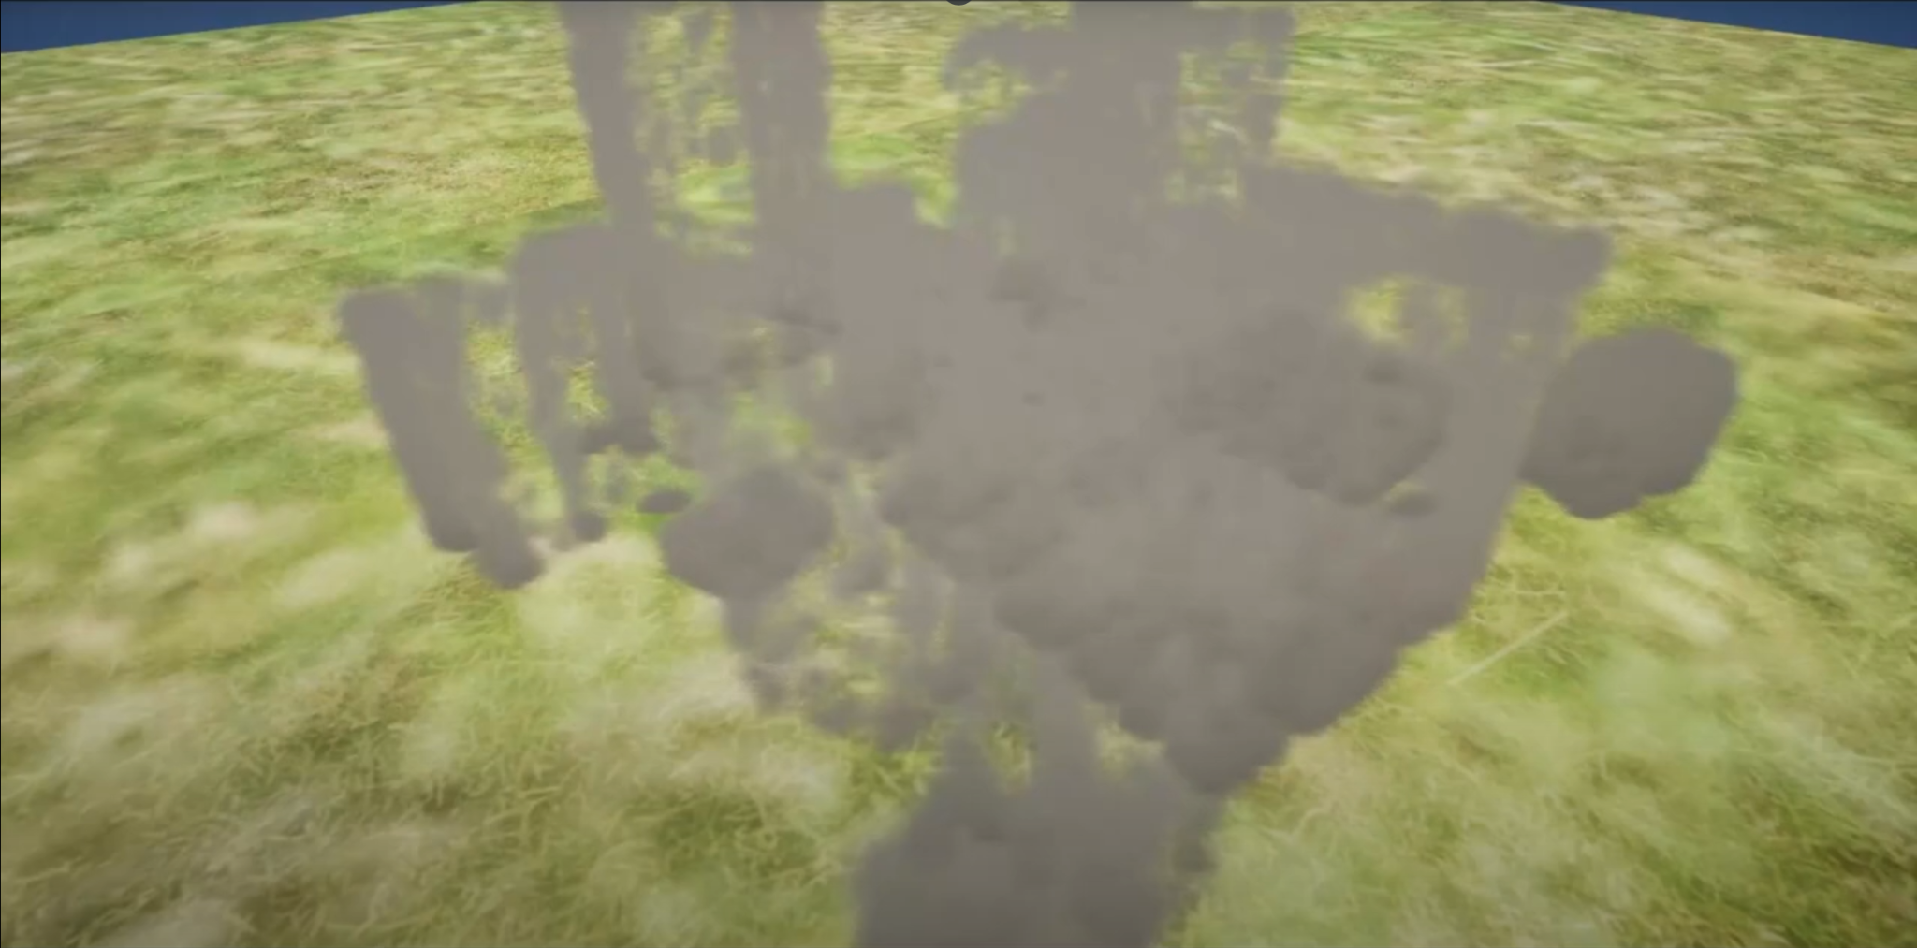

See <https://youtu.be/M2Zv-KJDNgs> for an example. The Unreal Engine’s particle effects system, Niagara, can instantaneously spawn numerous sprites on the skin of objects such as the buildings provided by the OSM data. With some added velocities for gravity and curl noise force, the dust falls away. Aerodynamic drag maintains a smoky aesthetic.

**Figure 7**

*Mesh Reproduction Sprite*

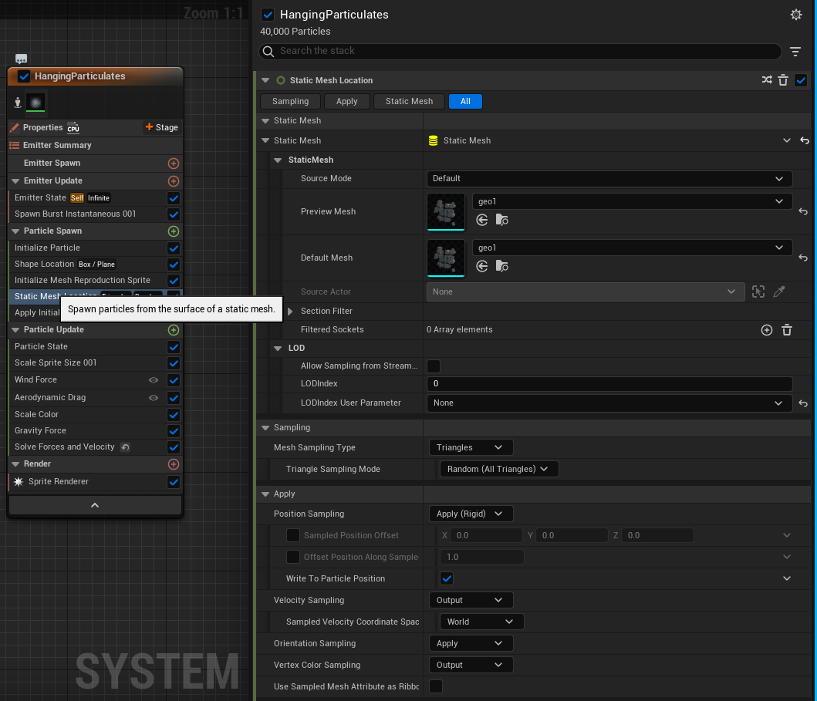

**Conclusion**

The integration of geospatial data from OpenStreetMap (OSM) into Unreal Engine presents a promising approach for achieving high levels of realism in virtual environments.The wealth of real-world information available through OSM tools can efficiently create expansive and authentic game worlds that meet the increasing demands of players. The multi-step integration process, facilitated by specialized tools and plugins, allows for the extraction and transformation of OSM data into 3D models suitable for real-time applications. While additional steps such as retopology may be necessary to optimize these models, the end result is a seamless integration of real-world elements into virtual environments, enhancing their fidelity and interactivity. Moving forward, further advancements in technology and tools will likely continue to refine and expand immersive gameplay.

**References**

Fricker, Mike. (2023, May 29). *ue4plugins/StreetMap.* GitHub. https://github.com/ue4plugins/StreetMap

Houdini. (2020, Mar 30). *City Building with OSM Data | Introduction*. YouTube. https://www.youtube.com/watch?v=FQ_DKhSyelY

Houdini. (2023, Nov 1). *Labs OSM Buildings geometry node*. YouTube. https://www.sidefx.com/docs/houdini/nodes/sop/labs--osm_buildings.html

Houdini. (2023, Nov 1). *ROP FBX Output TOP node*. YouTube. https://www.sidefx.com/docs/houdini/nodes/top/ropfbx.html

Houdini. (2020, Mar 30). *City Building with OSM Data | Part 1 | Prepare Open Street Map Data*. YouTube. https://www.youtube.com/watch?v=8YDWj0-QFVQ&list=TLPQMjcwMzIwMjTtnXBaJgUDCw&index=4

OpenStreetMap. (2004, Aug 16). *OpenStreetMap*. YouTube. https://www.openstreetmap.org/